**Section 1: Preparing the data**

I cleaned the data, mistakenly replacing missing values with the median value for the other questions accessing the same construct. However, in class I learned that this was incorrect. Instead I should have created means ignoring that data point. So for a construct that included 3 questions but was missing one data point, I should simply create an aggregate score consisting of the mean of the two data points I do have.

In the interest of time management and because I now know the correct procedure, I did not make the correction and am turning this assignment in with the mistake. I know this may mean I get some points deducted for the assignment, but in the interest of time management and to make room for other work I decided to leave it as is and add a note: I WILL NEVER FALSIFY DATA AGAIN, and I know the right way to deal with missing data now.

All of the other procedures should be done correctly, though the results will indeed be incorrect because of that initial mistake. I did, however, achieve what I think was the main intended insight. The distribution shapes and correlations were the same whether I was using the raw data, z-scores, or T-scores. This week I discovered the beauty and power of standardized scales, which for me is a breakthrough. This concept is adequately demonstrated in the following visualizations and raw output.

**Section 2: Analysis**

Frequency distributions and histograms for the variables Sex, Race, and Ethnicity:

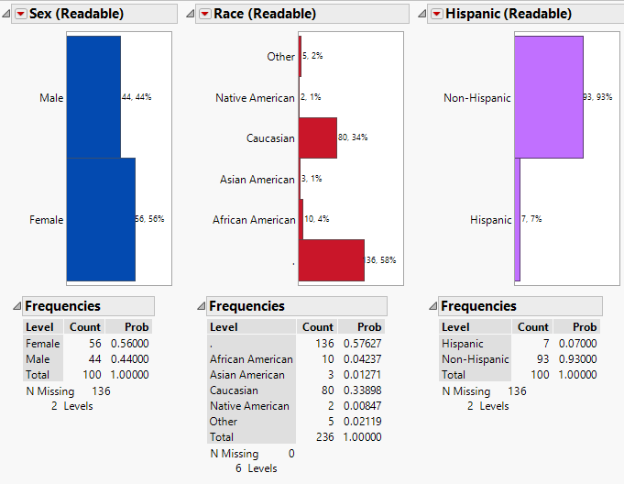

Basic summary statistics for all continuous variables. Mean is based on geometric mean values for the given variable.:

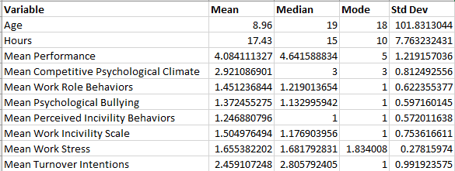

Relationship between variables *Mean Performance* and *Mean Work Stress* raw scores:

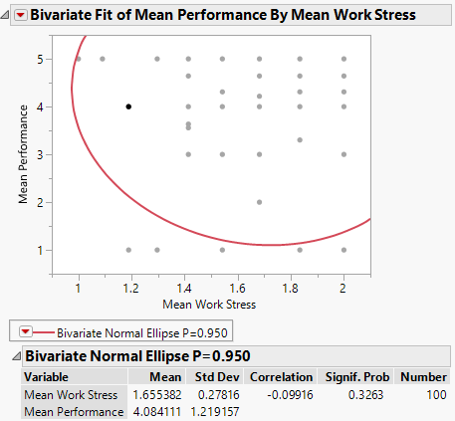

Quantiles for Z-scores of variables *Mean Performance* and *Mean Work Stress,* including maximum z scores, and relationship between variables *Mean Performance* and *Mean Work Stress* z-scores:

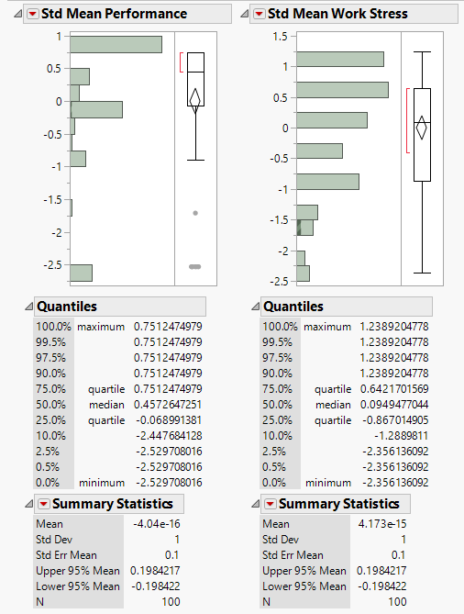 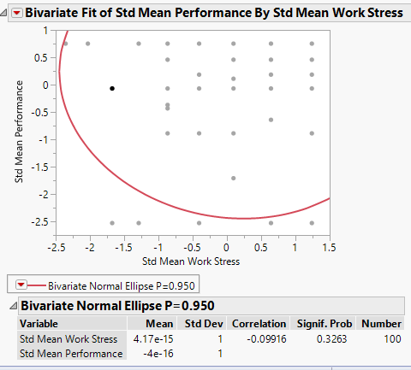

Quantiles for T-scores of variables *Mean Performance* and *Mean Work Stress,* including maximum T-scores, and relationship between variables *Mean Performance* and *Mean Work Stress* T-scores:

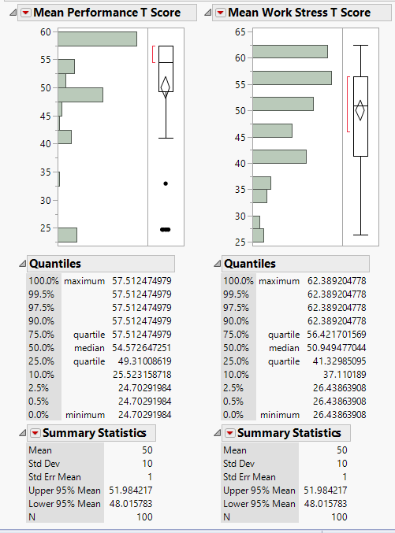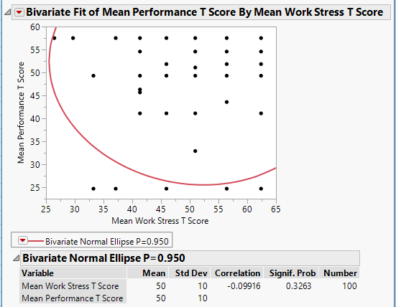

Frequency distributions and histograms for variables *Raw score job performance, z-score job performance, and T-score job performance:*

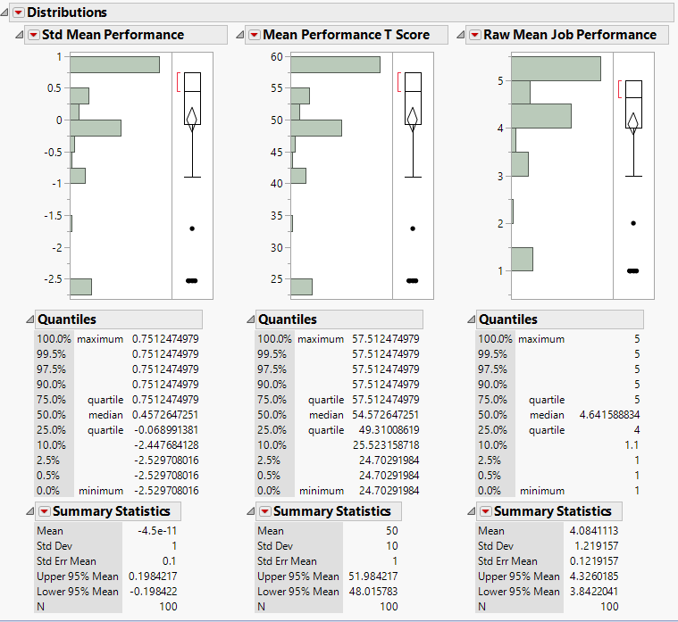

Relationship between variables *raw score job performance, z-score job performance, and T-score job performance*:

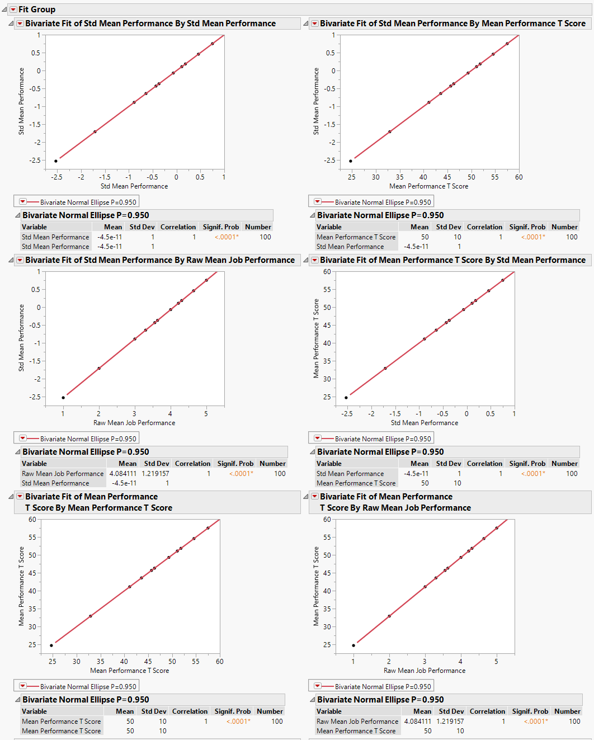

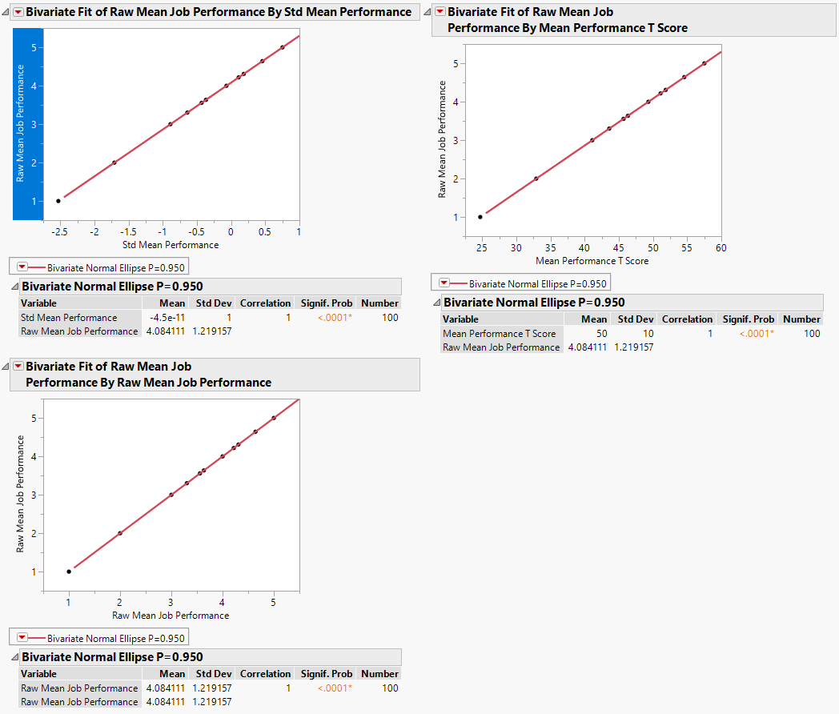

Sources used:

Histograms, Bar charts and Frequency Distributions in JMP: <https://www.youtube.com/watch?v=3stnhkJQLlg>

Correlating 2 Continuous Variables in JMP: <https://www.jmp.com/content/dam/jmp/documents/en/academic/learning-library/05-correlation.pdf>

Converting to z-scores in JMP: <https://community.jmp.com/t5/JMP-Academic-Knowledge-Base/Finding-Standardized-Values-z-Scores-OPG/ta-p/21638>

Equation to convert z-scores to T-scores: <https://www.google.com/search?client=firefox-b-1-ab&q=convert+z+score+to+t+score>

Using the function editor in JMP: <https://www.youtube.com/watch?v=HZCZ9b9WYUI>